The Anniversary, by Bill Macilwraith
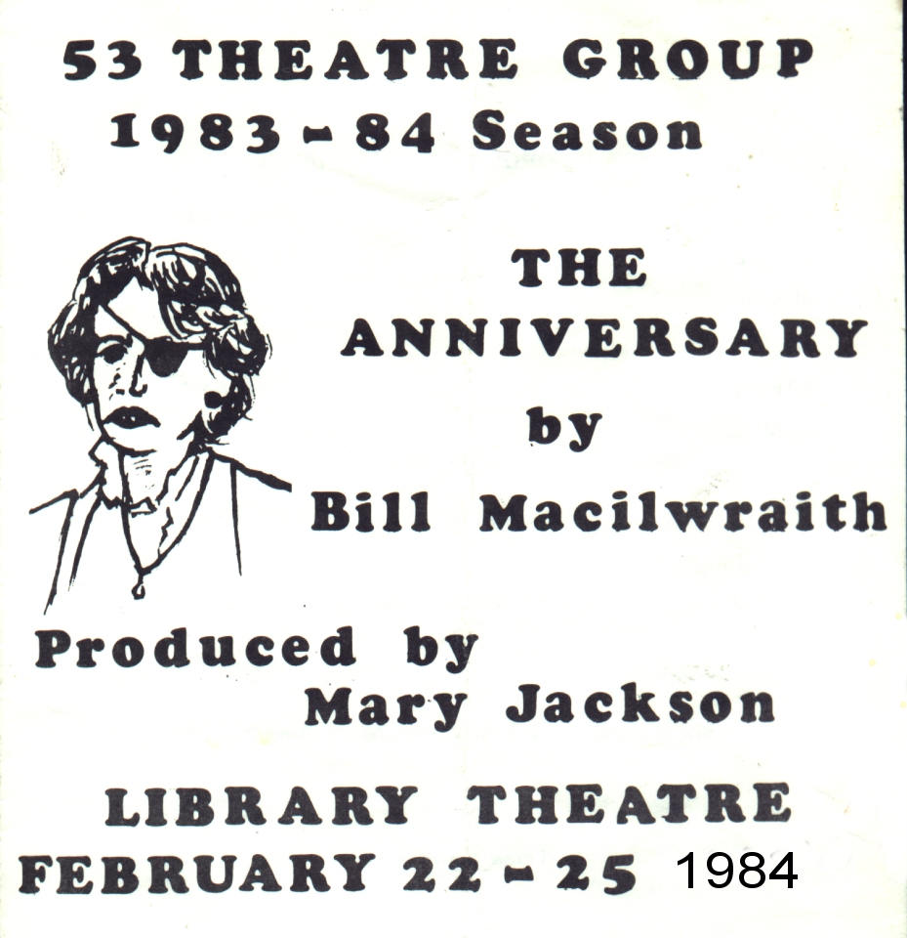
Produced by Mary Jackson
February 1984
Cast
Tom | Peter Wade
Shirley | Christine Czerwinski
Henry | Cary Griffiths
Terry | Darren Willan
Karen | Anne Ashby
Mum | Sheila Gascoyne

